(red color) is for explanation purpose, Please remove when you write your manuscript!
(Title)Intraspecific diet shifts of the sesarmid crab, Sesarma dehaani, in three wetlands in the Han River estuary, South Korea

(Authors)Dongwoo Yang^{1,3}, Donguk Han^{2,3} and Sangkyu Park^{1*}

(Affiliation)
¹Department of Biological Science, Ajou University, Suwon 16499, Republic of Korea

²School of Biological Sciences, Seoul National University, Seoul 08826, Republic of Korea

³Present address: National Marine Biodiversity Institute of Korea, Seocheon 33662, Republic of Korea

(Corresponding author information)
* Corresponding author:

Department of Biological Science, Ajou University, 206, World cup-ro, Yeongtong-gu, Suwon 16499, Republic of Korea
E-mail address: daphnia@ajou.ac.kr
Tel : +82 31 219 2967
Fax: +82 31 219 1615

(Keywords)

Keywords: Sesarma dehaani, Stable isotopes, Fatty acid biomarkers, Diets shift, Han River estuary

ABSTRACT
Background: Han River estuary is a national wetland reserve near the Demilitarized Zone (DMZ) between South Korea and North Korea. This trans-boundary estuary area has been well-preserved and shows distinctive plant communities along the salinity gradient. To elucidate energy flows and nutrient cycling in this area, we studied trophic relations between the dominant sesarmid crab, Sesarma dehaani, and food sources in three wetlands with different environments along the estuarine gradients.

Results: Stable isotope signatures (δ¹³C and δ¹⁵N) of the crabs were significantly different among the sites and body size classes. Seasonal changes in δ¹³C of small crabs were distinct from those of large individuals at all the sites. The isotopic values and fatty acid profiles of the crabs were more different among the sites in September than in May. In May, large sized crabs utilized more plant materials compared to other dietary sources in contrast to small sized crabs as revealed by a stable isotope mixing modeling, whereas contributions to diets of crabs were not dominated by a specific diet for different body size in September except at site 1. Based on PCA loadings, fatty acid content of 18:3ω3, known as a biomarker of plant materials, was main factor to separate size groups of crabs in May and September. The δ¹³C value of sediment had high correlation with those of small sized crabs at site 1 and 2 when one month time lag was applied to the value for crabs during the surveyed period.

Conclusions: Based on the stable isotope and fatty acid results, the consumption habits of S. dehaani appear to be distinguished by sites and their size. In particular, smaller size of S. dehaani appears to be more dependent on fewer food sources and is influenced more by the diet sources from the sediments in Han River estuary.

Background
To elucidate ecosystem functions, such as energy flows and nutrient cycling, it is essential to understand the trophic relations of dominant organisms in food webs (Vander Zanden et al. 2006). The food webs in estuaries are complex; they incorporate different environments, such as terrestrial and brackish environments, and provide diverse habitats as well as different food sources for various organisms based on hydrological fluctuation (Peterson 1999; Nagelkerken et al. 2008; Kristensen et al. 2008). Numerous studies on estuarine food webs have been conducted for comparisons with habitats with a salinity gradient from riverine mouth to offshore, possessing different vegetation types (Lee 2000; Doi et al. 2005; Choy et al. 2008; Antonio et al. 2012; Bergamino and Richoux 2015). Several studies have focused on food webs in mangrove systems in subtropical and tropical regions (Kristensen et al. 2008; Lee et al. 2014); they have especially focused on the interactions between mangroves and crabs, such as grapsid and sesarmid crabs, which have been reported to be major players in carbon cycling in these systems and primarily consume mangrove litters and propagules (Lee 1998).
…
In this study, we extended our previous investigation wherein we elucidated trophic relations between the sesarmid crab, S. dehaani, and food sources, particularly plant material and sediment, with respect to the size of crabs in the upper brackish areas, to three wetlands dominated with different plant species along the estuarine gradients in the Han River. In this regard, we estimated the diet contributions of the crabs, grouped by size, based on carapace width and seasonal change using stable isotope and fatty acid analyses with a stable isotope mixing model in three different sites with different vegetation and marine influence.

Materials and Methods
(Sub-title may be different for each manuscript!)Study area
The Han River runs through the middle part of the Korean peninsula, penetrating through Seoul to reach the Yellow Sea. The Han River estuary lies inside the Demilitarized Zone (DMZ) between South and North Korea (37° 36′ 56″ N, 126° 47′ 38″ E–37° 46′ 36″ N, 126° 31′ 34″ E). We studied three different wetlands encompassing a spatial gradient of environmental conditions. The Janghang wetland, containing site 1, is located 31.7 km upstream of the river mouth whereas the Gongreung wetland, containing site 2, and Seongdong wetland, containing site 3, are 18.3 and 14.4 km upstream, respectively (Fig. 1).
…

(Sub-title may be different for each manuscript!)Sample collection and preprocessing
The sesarmid crab, the characteristic marsh plants (S. subfragilis for site 1, P. communis for site 2, and B. planiculmis and P. communis for site 3), and sediment were collected from the three sites every month between August, 2006 and November, 2007 except during the winter season (November, 2007 for site 2 and October and November, 2007 for site 3) when the crabs hibernated in their burrows and access to them was restricted. The crabs caught by hand from each study area were classified into four size groups, namely Group I (~10–20 mm), Group II (~20–30 mm), Group III (~30–40 mm), and Group IV (larger than 40 mm), based on its carapace width.
…

(Sub-title may be different for each manuscript!)Stable Isotope analysis
All the samples were dried using a freeze dryer (Model FD2.5; Heto, Waltham, USA). The freeze-dried samples were further dried at 60°C in an oven for 48 h and subsequently ground into powder using pestle and mortar. …
The δ¹³C and δ¹⁵N values were expressed as differences (in parts per thousand, ‰) in ¹³C:¹²C and ¹⁵N:¹⁴N ratios (R), respectively, between the samples and the standards [Pee Dee Belemnite marine limestone for ¹³C and atmospheric nitrogen for ¹⁵N], as follows:

$$δ^{13}C or δ^{15}N \left(‰\right)= \left[\frac{R_{sample} – R_{standard}}{R_{standard}}\right] × {10}^{3}$$
$$R{= }^{13}C/^{12}C o{r }^{15}N/^{14}N$$
…

(Sub-title may be different for each manuscript!)Data analysis
The body size and spatial difference in the stable isotope signatures of S. dehaani captured in all the seasons were identified by performing a two-way analysis of variance (ANOVA). This analysis used “Size Group” and “Site” as the two factors. PCA was conducted to compare the fatty acid compositions of crabs among the size groups and habitats. Prior to PCA, log transformations were applied to ensure the homogeneity of variance; this was followed by Pareto scaling to improve the fatty acid information content (van den Berg et al. 2006). To compare the stable isotope signatures and FA profiles of the crabs between the size classes and among sites, multivariate analysis of variance (MANOVA) was conducted (Cherel et al. 2000; Delaporte et al. 2005). MANOVA can examine whether the averages of the combined values of δ¹³C and δ¹⁵N or PCA score of FA profiles are significantly different between the size groups or among sites.
…

Results
(Sub-title may be different for each manuscript!)Isotopic signatures of Sesarma dehaani during the entire period
The results of the two-way ANOVA on stable isotope signatures of S. dehaani sampled during the entire period of study, revealed significant differences among the crab size classes and among the different sites. The percent of variance explained by the site factor was higher than that explained by the size factor on both δ¹³C and δ¹⁵N of S. dehaani, especially on δ¹⁵N (Table 1). The δ¹³C and δ¹⁵N values of the crabs were respectively within certain ranges for each site; -25.2‰ ± 1.2 and 8.3‰ ± 1.0, n = 174 at site 1, -24.6‰ ± 1.6 and 9.7‰ ± 0.9, n = 62 at site 2, -22. 0‰ ± 2.3 and 11.3‰ ± 1.0, n = 58 at site 3. (Fig. 2).

(Sub-title may be different for each manuscript!)Diet source contributions by size groups in two seasons
To compare the effect of the surrounding circumstances on the contributions of diet to S. dehaani in detail, we selected two seasons for the analyses. The season during May provides a short time for the utilization of diets after hibernation, and the season during September provides more time for feeding as well as a wide range of diets compared to the spring. In addition, the monsoon rainfall during the summer influences their feeding between the two seasons.
…

(Sub-title may be different for each manuscript!)Trophic relations between sediment and Sesarma dehaani
Comparisons of the δ¹³C values of both the sediment and S. dehaani revealed that the values for individuals in group I and II were closer to those of the sediment compared to those of group III and IV (Fig. 6).

…

Discussion
The results of this study suggest that the consumption of food by the sesarmid crab, S. dehaani, was influenced by the landscape heterogeneity. Moreover, shifts in the feeding habits of S. dehaani between the size classes in the lower brackish area (site 3), which was less vegetated, were unclear compared to those in the upper area (site 1), which was densely forested by the Salix community. Sesarma dehaani had spatial differences in the isotopic signature, showing patterns similar to those of the benthic consumers, including sesarmid crabs, along the salinity gradient in estuarine ecosystems (Table 1 and Fig. 2, Bouillon et al. 2004; Doi et al. 2005; Bergamino and Richoux 2015).
…

Conclusions
In conclusion, we determined the contributions of major food sources for S. dehaani, which is a dominant consumer species in the Han River estuary, where human influences are low. Food sources of S. dehaani were mainly influenced by the habitats, especially for small sized individuals. Sesarma dehaani at site 1 and site 2 in the upper estuary region were influenced more by the food sources of terrestrial origin whereas the crabs at site 3, which was more open and closer to the marine environment, were more influenced by the marine phytobenthos.
…

ABBREVIATIONS
ANOVA: Analysis of Variance, DMZ: Demilitarized Zone, FA: Fatty Acid, FAMEs: Fatty Acid Methyl Esters, FID: Flame Ionization Detector, IRMS: Isotope Ration Mass Spectrometer, MANOVA: Multivariate Analysis of Variance, MPB: Microphytobenthos, PCA: Principal Component Analysis, PTV: Programmable Temperature Vaporizer, SIAR: Stable Isotope Analysis in R

ACKNOWLEDGEMET
This research was supported by the Basic Science Research Program through the National Research Foundation of Korea (NRF) funded by the Ministry of Education, Science and Technology (No. 2013R1A1A2011780)

FUNDING

This research was supported by the Basic Science Research Program through the National Research Foundation of Korea (NRF) funded by the Ministry of Education, Science and Technology (No. 2013R1A1A2011780)

AVAILABILITY OF DATA AND MATERIALS

The datasets generated during and/or analyzed during the current study are available from the corresponding author on reasonable request.

AUTHORS’ CONTRIBUTION

DY carried out the field study and performed the analysis, and wrote the manuscript. DH participated in the design of the study, conducted field study, reviewed the manuscript. SP conceived the study and reviewed/edited the manuscript. DY and DH made equal contributions to this study. All authors read and approved the final manuscript.

ETHICS APPROVAL AND CONSENT TO PARTICIPATE

Not applicable.

CONSENT FOR PUBLICATION

Not applicable.

COMPETING INTEREST

The authors declare that they have no competing interests.

Table 1. Results of two-way ANOVA comparing the impacts of size groups (Group) and habitats (Site) of Sesarma dehaani on the values of δ¹⁵N and δ¹³C for the entire period of study

δ¹⁵N value |  |  |  |  |  | δ¹³C value
Source | df | F | p | % of variance explained |  | Source | df | F | p | % of variance explained
Group | 3 | 10.87 | < 0.001 | 3.70% |  | Group | 3 | 5.40 | 0.001 | 3.00%
Site | 2 | 270.01 | < 0.001 | 60.60% |  | Site | 2 | 108.41 | < 0.001 | 40.70%
Group × Site | 6 | 5.88 | < 0.001 | 4.00% |  | Group × Site | 6 | 2.68 | 0.015 | 3.00%
Residual | 283 |  |  | 31.80% |  | Residual | 283 |  |  | 53.20%

Table 2. Results of MANOVA based on the values of δ¹³C and δ¹⁵N of Sesarma dehaani grouped by carapace width among the different sites in May and September, 2007

Size  Group | May 2007 |  |  |  |  |  | September 2007
 | Lambda | p | Sites | T² | p |  | Lambda | p | Sites | T² | p
Group  I – II | 0.067 | < 0.001 | St.1- St.2 | 14.424 | 0.001 |  | 0.022 | < 0.001 | St.1- St.2 | 40.744 | < 0.001
 |  |  | St.2- St.3 | 14.384 | 0.001 |  |  |  | St.2- St.3 | 27.125 | < 0.001
 |  |  | St.1- St.3 | 59.395 | < 0.001 |  |  |  | St.1- St.3 | 136.352 | < 0.001
Group  III - IV | 0.174 | 0.002 | St.1- St.2 | 5.154 | 0.032 |  | 0.279 | 0.003 | St.1- St.2 | 3.311 | 0.072
 |  |  | St.2- St.3 | 1.654 | 0.245 |  |  |  | St.2- St.3 | 3.234 | 0.075
 |  |  | St.1- St.3 | 16.634 | 0.001 |  |  |  | St.1- St.3 | 15.176 | 0.001

Figure legends

Fig. 1 Location of sampling sites in the Han River estuary, South Korea: site 1 (Janghang wetland), site 2 (Gongreung wetland), and site 3 (Sungdong wetland)

Fig. 2 Dual isotope plots of δ¹³C and δ¹⁵N mean values (± SD) for all sized groups of Sesarma dehaani at the site 1, site 2 and site 3 in the Han River estuary in whole studied period

Fig. 3 δ¹³C and δ¹⁵N diagram of the Han River estuary wetland in the (a) early season after hibernation (May 2007) and (b) in the active season of foraging (September, 2007)

Fig. 4 Mean percentage contributions (95% credibility interval) of food sources (plant materials, sediment, and microphytobenthos; MPB) to Sesarma dehaani at the three studied sites of the Han River estuary in May and September, 2007

Fig. 5 Scores of principal component analysis based on the fatty acid profiles of Sesarma dehaani of each size class at site 1, 2, 3 in May, 2007 (a) and September, 2007 (b). Symbols indicate sites, circle: site 1, triangle: site 2 and square: site 3. Closed symbols indicate Group I-II. Open symbols indicate Group III-IV

Fig. 6 Relationship between the δ¹³C values of detrital sediment and Sesarma dehaani in the three wetlands for the entire period of study. Symbols indicate size classes, circle: Group I-II, triangle: Group III-IV. Open symbols indicate that one month time lag was applied to the values for crabs

(Please submit your figures together with main manuscript in one word file. Once your manuscript is accepted. You will be asked to submit your figures as independent files)
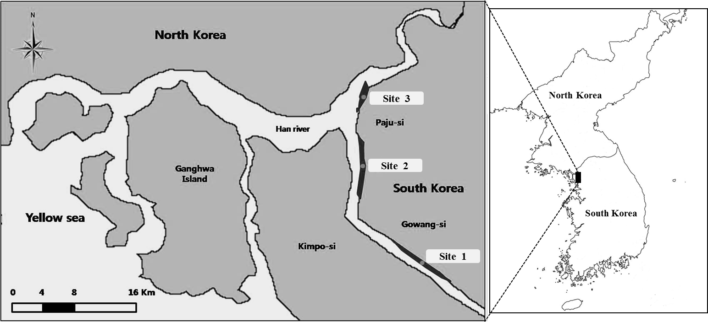
Fig. 1

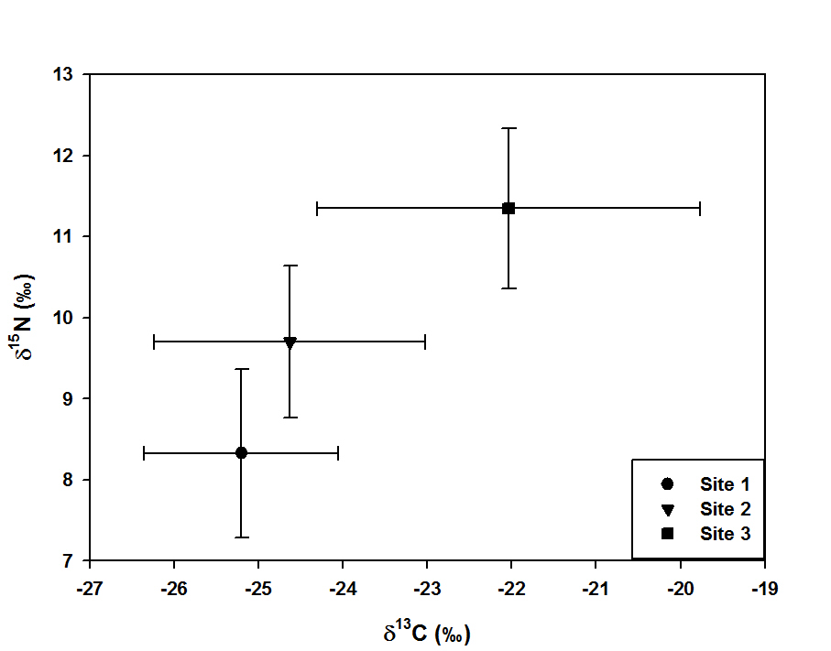
Fig. 2

References
Antonio ES, Kasai A, Ueno M, Ishihi Y, Yokoyama H, & Yamashita Y. Spatial-temporal feeding dynamics of benthic communities in an estuary-marine gradient. Estuar Coast Shelf Sci. 2012;112:86-97. (Article within a journal)
Baek KO, Yim DH. Flow characteristics induced by shift and modification of submerged weir at Han River estuary. J Kor Soc Civil Eng. 2011;31:109-119. (Article within a journal)
Blenkinsopp A, Paxton P. Symptoms in the pharmacy: a guide to the management of common illness. 3rd ed. Oxford: Blackwell Science; 1998. (Complete book, authored)
Doe J. Title of subordinate document. In: The dictionary of substances and their effects. Royal Society of Chemistry. 1999. http://www.rsc.org/dose/title of subordinate document. Accessed 15 Jan 1999. (Online document)
Frumin AM, Nussbaum J, Esposito M. Functional asplenia: demonstration of splenic activity by bone marrow scan. Blood 1979;59 Suppl 1:26-32. (Article within a journal supplement)
Healthwise Knowledgebase. US Pharmacopeia, Rockville. 1998. http://www.healthwise.org. Accessed 21 Sept 1998. (Online database)
Parnell AC, Inger R, Bearhop S, Jackson AL. Source partitioning using stable isotopes: coping with too much variation. PloS One. 2010;5:e9672. (Article within a journal (no page numbers))
Saito Y, Hyuga H. Rate equation approaches to amplification of enantiomeric excess and chiral symmetry breaking. Top Curr Chem. 2007. doi:10.1007/128_2006_108. (OnlineFirst chapter in a series (without a volume designation but with a DOI))
Slifka MK, Whitton JL. Clinical implications of dysregulated cytokine production. Dig J Mol Med. 2000; doi:10.1007/s801090000086. (Aticle within a journal by DOI)
Wyllie AH, Kerr JFR, Currie AR. Cell death: the significance of apoptosis. In: Bourne GH, Danielli JF, Jeon KW, editors. International review of cytology. London: Academic; 1980. p. 251-306. (Book chapter, or an article within a book)

